OWSD General Assembly 2021- Poster Submission Form
Name: | Surname:
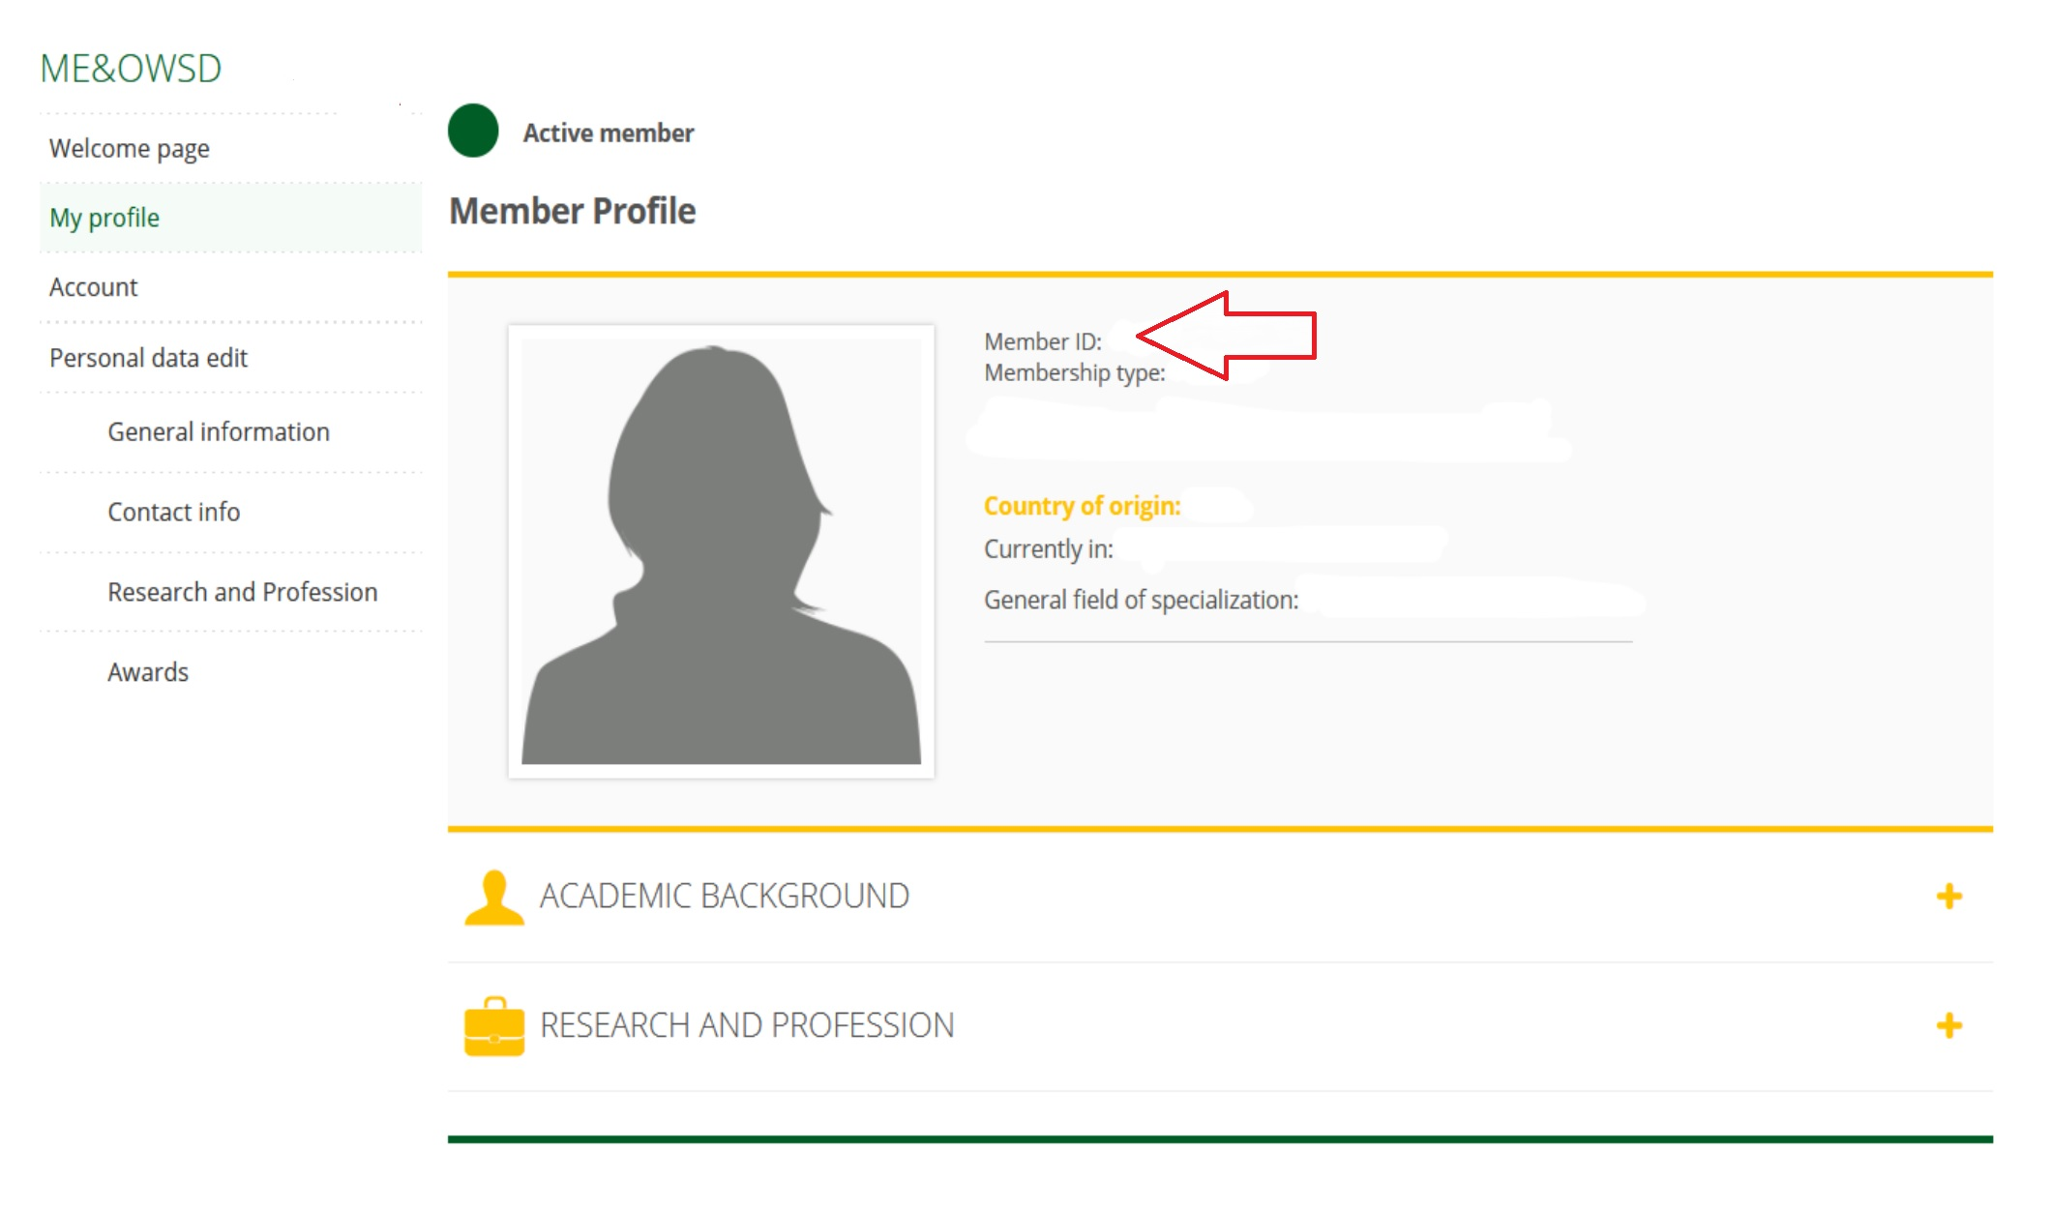
OWSD Membership I.D. Number:
(you have to login to your
online profile in order to see it):

Affiliated Institute (if any):

Country of Nationality: | Country of Residence:
Selected poster theme (you may submit a poster to more than one theme. If you do, please check all relevant themes and submit as attachments to the same email):

- OWSD members’ responses to COVID 19 | - Applied science: results for development
- The importance of basic sciences for development | - Including sex and gender as variables in scientific research
Please select your career stage:

- Master’s or PhD Student | - Postgraduate
- Early career | - Senior / other
Please tick if you are:

- An OWSD PhD Fellowship grant holder or Alumna | - An OWSD Early Career Fellowship grant holder or Alumna
- An OWSD-EF Awardee | - None of the above

